


User Manual
IE-POWER 3/4 Fuel Cell Module

Users must read all instructions provided and retain the manual for future reference.

Original Instructions. Version 1.

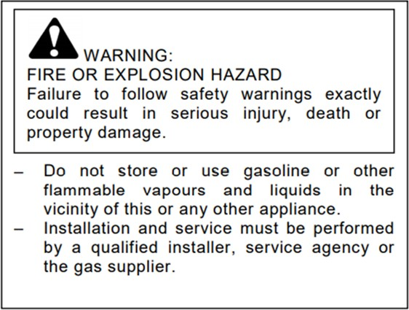

This User Manual is intended as a general guidance only and does not purport to address the specific situations that could potentially arise from the use of fuel cell module systems and their usage in connection with all stationary power, portable power, and Industrial Truck (MHE) applications. The recipient is responsible for ensuring that all personnel have read and understood this User Manual before being allowed to handle, operate, install, and store any equipment supplied by Intelligent Energy.
The recipient must ensure that any personnel responsible for operating the fuel cell module for stationary power, portable power, and Industrial Truck (MHE) applications are suitably trained and certified in compliance with any applicable local, state, and federal laws and regulations and good industry practice. The recipient is responsible for complying with any relevant health and safety policies and procedures that may apply to the operation of stationary power, portable power, and Industrial Truck (MHE) applications and use and storage of hydrogen on any sites. Intelligent Energy has a limited product warranty to the recipient that it will repair and replace any defective equipment resulting from the authorised use of the equipment provided, full terms and conditions available on request. Notwithstanding the above, Intelligent Energy, to the fullest extent permitted by law, accepts no liability (including liability in respect of any error or defects in the fuel cell module system) for any damage caused as a result of recipient’s unauthorised use of the equipment provided. The recipient acknowledges that the manner in which the equipment is stored, used, or operated is not under the control of Intelligent Energy Limited. Intelligent Energy has made every effort to ensure that this User Manual is accurate and disclaims liability for any inaccuracies or omissions that may have occurred.
Glossary of terms:

- IE - Intelligent Energy Ltd

- FCM – Fuel cell module

- MHE – Material handling equipment

- APU – Auxiliary power unit

- POC – Performance optimisation cycle (see section 8.3)

- CAN – Controller area network

- BMS – Battery management system

- PE – Protective earth

- EMC – Electromagnetic compatibility

- ESD – Electrostatic discharge

- EMI – Electromagnetic interference

- VOCs – Volatile organic compounds

- LEL – Lower explosive limit

- LED –Light emitting diode

- DVM – Digital voltmeter

- DMM – Digital multimeter

- PPE – Personal protective equipment

- ROHS – Restriction of hazardous substances

- CE – European conformity

- FCC – Federal Communications Commission

Table of Contents
Users must read all instructions provided and retain the manual for future reference. 1
1 Safety and warnings 4
1.1 Fuel cell air supply and ventilation requirements.…………6
1.2 Stationary Power: Certification standards and installation regulations..……………………………………………………………………7
2 Product specification 8
3 Parts of the IE-POWER 3/4 9
4 Product interface 10
5 IE-POWER 3/4 overview 10
6 Connections 11
6.1 Electrical configuration 11
6.2 Electrical isolation and over-current protection 12
6.3 Air supply 12
6.4 Hydrogen fuel 13
6.5 Hydrogen connection 13
6.6 Communication connection 13
6.7 CAN connection 14
6.8 Potential free contacts 14
7 FCM commands and status 15
7.1 Module enable 15
7.2 Module run 15
7.3 P3/P4 status 15
7.4 P3/P4 software states 16
8 Operation of IE-POWER 3/4 17
8.1 Overview P3/P4 17
8.2 Anode Purge 17
8.3 Fan Pulse 17
8.4 Standby State 17
8.5 Fault State 17
8.6 Optimising the Fuel Consumption of P3/P4 18
9 Faults 18
9.1 Procedure to reset the fault 18
10 Installation and set up 19
10.1 Mechanical mounting points 19
10.2 Mechanical protection and covers 19
10.3 Mechanical connection to the power terminals 20
10.4 Mechanical connection to the Ground terminal 20
10.5 Vibration and shock loads 21
10.6 Air supply and ventilation 6
10.7 Hydrogen connection 21
10.8 Hydrogen fuel physical requirements 21
11 Maintenance procedures 22
11.1 User maintenance 22
11.2 Contact Intelligent Energy Product Support Team 22
12 Troubleshooting guide 23
12.1 Possible causes of faults 23
12.2 Check for fuel leak 23
12.3 Fuel check procedure 23
12.4 Electrical system check procedure 25
12.5 Stack temperature check procedure 26
12.6 Filter change procedure 26
13 Control parameters and standard factory setting 27
13.1 Power setup configuration (P3) 27
13.2 Power setup configuration (P4) 27
14 Spare parts, storage and disposal 28
14.1 Spare parts 28
14.2 Disposal 28
14.3 Storage 28
14.4 Transportation 28
15 Declaration of Conformity 29

Safety and warnings

- In case of an emergency
- Stop power generation from the fuel cells by disconnecting the FCM enable pin
- Isolate the DC supply (application specific)
- Isolate the fuel supply (application specific)

- Warning: Fire or explosion hazard
- Failure to follow safety warnings exactly could result in serious injury, death or property damage.
    - Do not store or use gasoline or other flammable vapours and liquids in the vicinity of the FCM(s)
    - Installation and service must be performed by a qualified installer, service agency or gas supplier

The Fuel Cell Modules (FCM) IE-POWER 3 (P3) and IE-POWER 4 (P4) use hydrogen gas to provide electrical DC power. They must only be used by personnel who have been trained for the safe use of the products by Intelligent Energy.

The FCM is designed for heavy industrial applications. The safety assessment applied to this product considers its use to be limited to non-essential / non- critical applications or where it is the back-up to another form of power supply rather than being the primary source.

This is an important distinction and particularly in the systems response to failure, in this case the response to failure is to shut down the output, normally by isolating the hydrogen supply. This course of action would not be appropriate where it is intended as the single source of supply or in the provision of critical supplies to, for example medical equipment, emergency lighting, interlocking, etc.

Where the intended use is outside that assessed by Intelligent Energy, the customer must assess and design their system appropriately with regard to this limitation.



- High current electrical hazard is present
- Risk of electric shock, be aware of consequential injury
- There is a risk of residual voltage on live component after shutdown
- Do not electrically overload the P3/P4
- Pressurised hydrogen present, highly flammable!
- Ensure hydrogen supply can be isolated in case of an emergency
- Unit must be inspected for damage and leak checked prior to use
- Fault diagnosis must be carried out by trained and competent personnel only
- Do not use this fuel cell if any part has been underwater. A flood damaged fuel cell is potentially dangerous. Attempts to use the fuel cell can result in fire or explosion. No naked flames in the vicinity of hydrogen operation area
- Do not remove the air filter while operating
- Do not remove the external covers
- Keep operational area free from combustible materials
- Do not obstruct air flow to inlet or exhaust
- The terminal cover must always be fitted except during installation and maintenance
- For use in a ventilated indoor environment, or
- For use in a weather protected outdoor environment; must protect from wind and rain ingress
- Environmental protection required from snow, excessive dust and vegetation
- Do not use FCM if there is water visible on it
- Do not install equipment above FCM that could release flammable/corrosive material on the module e.g. batteries
- Do NOT electrically overload the P3/P4. Overloading will lead to excessive load being drawn from the battery. Drawing excessive load may lead to a shutdown of the fuel cell and load not being supported
- When the P3/P4 is running it will stay live if the power cables are disconnected
- EVEN when the P3/P4 is NOT running the cables may still be powered from the load side battery or external power source
- Do not use the power ground as a reference for the communications and vice versa
- Ensure communication cables are not more than 3m long
- During installation and maintenance, the FCM must be off and the load side battery or external power supply must be made safe
- Additional certification standards and installation regulations apply when the fuel cell module is operating in either an Indoor or Outdoor location, please refer to section 1.2 for additional details and safety measures

Fuel cell air supply and ventilation requirements

The P3/P4 requires a free supply of clean air to deliver power output. The unit will require up to 16 Sm³ /min of unrestricted air flow. The operator must consider the air flow required for the environmental conditions expected.

The enclosure must not unduly restrict the air flow. The covers must be designed such that the exhaust gas cannot be recirculated into the air inlet.

As part of the design, the main air flow is also used to manage the risk of a hydrogen build-up internal of the unit. The hydrogen purge gas is routed into the air flow such that it is diluted to below the low flammability limit at the point of exit from the unit; therefore, the installer must take care not to restrict the exhaust stream. Also, this gas stream will contain hydrogen, this is at a concentration where it is not flammable. However, the air exhaust design must consider the hydrogen risk.

Note: The P3/P4 should be set up in a well-ventilated environment with sufficient clean air turn over or extraction:

The FCM is not able to detect leaks/ hydrogen releases that occur externally to it. This includes those on the supply to it. The FCM is not able to isolate the external supply during such an event. The FCM operates at relatively low pressure, a high-pressure storage cylinder and ancillary installation equipment has a much higher capacity to leak than the FCM itself.

The FCM P3/P4 consumes oxygen as it operates, this is inherent of the technology. There is a risk of asphyxiation.

This may include but not limited to; Zoning calculations, Hydrogen monitoring and/or oxygen monitoring.

The integrator is responsible for the safety of the whole installation including hydrogen storage, supply, generation, ventilation, batteries and any other equipment or infrastructure. This is the responsibility of the integrator to manage safely and in accordance with local laws and regulations.

The P3/P4 must be provided with free venting air in the range of +5 to +40°C, it must not be operated outside this range. The installation of the P3/P4 must consider other equipment near P3/P4 may elevate the local ambient temperature during their operation. A local increase of ambient temperature may affect the performance of the fuel cell. Do not use if the air has contaminants such as smoke, volatile organics or corrosive gas present.

Warning: Hot air that is generated by other equipment within 0.6m of the inlet of the P4 is of concern and should be limited to 5% of expected operating power of the P3/P4 in order to limit the ingestion of hot air.

1.2 Stationary Power: Certification standards and installation requirements

Application | EN IEC standard | Location | Safety measures
Defined as:  Application ‘bolted down’ and ‘fixed’ in an installation.  Application is a small part of the installation.  Whole installation can be moved, however planning and lifting equipment would be required.  Application is off when moved.  Can be a vehicle APU, that provides power when vehicle is stationary.  E.g., H₂ powered ‘Cell Site/Base Transceiver Station (BTS)’, data centre, welfare cabin, vehicle movable lighting tower. | EN IEC 62282-3-100:2020  Fuel cell module technologies - Part 3-100: Stationary fuel cell module power systems - Safety | Indoor  >10kW | Use FORBIDDEN unless additional depleted oxygen detection and hydrogen detection is added with ADDITIONAL overall use certification.
 |  | Outdoor  >10kW | Evaluate additional outdoor environmental requirements including wind, rain, dust, and ingress protection incorporate as part of system integration.¹
 |  | Indoor  <10kW | Ensure safety ventilation advice is followed, see 1.1
 |  | Outdoor  <10kW | Evaluate additional outdoor environmental requirements including wind, rain, dust, and ingress protection incorporate as part of system integration.¹

1) Outdoor application should normally have sufficient ventilation. If a particular outdoor application has any restrictions to ventilation, then ensure safety ventilation advice is followed (see section 1.1).

Product specification

Performance | Rated net power ^{1, 9} | 48V: 2.4kW (P3) 4.0kW (P4)  24V: 1.92kW (P3) 2.88kW (P4)
 | Output voltage regulation | to ETS 300-132-2
 | Rated current | 48V: 50A (P3) 80A (P4)  24V: 80A (P3) 120A (P4)
 | Emissions | Water vapour
Fuel | Fuel type | Hydrogen gas
 | Fuel pressure | 650mbar.g ±150mbar.g
 | Fuel consumption | Less than 70g per kWh ²
 | Fuel storage | External storage available separately  Compatible with reformer technology or compressed hydrogen gas
 | Fuel composition | 99.9% gaseous hydrogen or better ³
Operations and maintenance | User interface | Options available ^{4,7}
 | Start-up time | Less than 10s
 | Automatic start/stop | Standard
 | Manual start/stop | Available
 | IP rating | IP20 ⁷
Safety and health monitoring | Certification | Designed in accordance with CE requirements ⁵
 | Health monitoring | Options available ^{6,7}
Physical | Mass | ~18kg (P3) ~20kg (P4)
 | Max dimensions | 448mm (W) × 306mm (H) × 473mm (D) ⁸
 | Connections, gas | G1/8 parallel BSP threaded port with face seal, female
 | Connections, electrical | Power bolt 2 × M8, GND Stud 1 × M8,  1 × FCM run input,  1 × FCM enable input, 1 × CAN hi/low/GND,  1 × 30mA driver (status),  4 × PFC
Normal operating conditions | Altitude | 0 – 4000m ^{7,9}
 | Operating ambient temperature range | +5°C to +40°C ⁹
 | Relative humidity | 10% to 90% ^{7, 9}
 | Storage temperature | -40°C to +70°C

1 >95% duty cycle

2 Achieved at 25°C, beginning of life

3 According to quality specified in BS 14687-3:2014(E)

4 CAN interface can be provided, see section 6.5

5 For details see Declaration of Conformity

6 Options available for continuous health monitoring

7 Please contact Intelligent Energy to discuss your requirements

8 Allow space for power cables and hydrogen connection to rear

9 Derated power when system and integration is not optimised, including combinations of:

High ambient temperature, >30°C

High altitude, >1500m

Low RH, <30%"

Parts of the IE-POWER 3/4

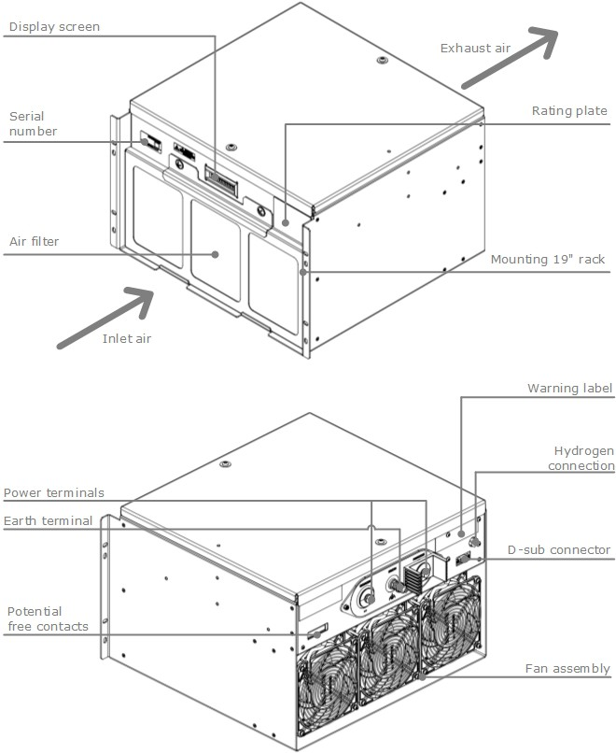

Product interface

Performance | Function | Specification
Hydrogen inlet  500mbar.g – 800mbar.g | Fuel supply | G1/8 parallel thread, with face seal
Air inlet  0-16 Sm³/min  5–40°C | Ambient air filtration and supply | 510 × 240mm duct
Exhaust air  0-16 Sm³/min  5–60°C | Air exhaust to ambient | 3 × 140mm dia. duct
Power connection  15.0–56.0V | Connection to DC bus | M8
Communication port  See section 6.5 | Operational commands & diagnostics | D type 9 way

IE-POWER 3/4 overview

This manual sets out an operating overview for Intelligent Energy’s P3 and P4 FCMs. The P3 and P4 FCMs are part of the IE-POWER product line, which also feature an IE-POWER 1 which can provide power up to 1.2kW.

The P3/P4 provides regulated DC at nominal output voltage, which can be defined by the user at a nominal 24V or 48V. The P3/P4 will hold the DC output at the nominal voltage while connected to an external battery or power supply so that the system will act as a hybrid system. In the hybrid system, the battery is used to provide power whilst the fuel cell starts, supports the load during the fuel cell Performance Optimisation Cycle (POC) and in the standby state. Hydrogen gas must be provided at a regulated pressure to the module inlet. The P3/P4 will generate power when it is given both Enable and Run signals (see Section 7.1 & 7.2).

During normal operation, the P3/P4 will conduct a POC where power delivery is briefly interrupted. In this period, the fuel cell will hybridise with the external battery (see Section 8.3 Performance Optimisation Cycle (POC)). If during normal operation the load drops to a low level (less than 6A, as default for the P4), the fuel cell will enter a standby state (see Section 8.4 Standby State). This is designed to optimise fuel consumption. If the DC Bus voltage then dips below a pre-set voltage, the fuel cell will restart.

During normal operation, the P3 or P4 will periodically conduct an optimisation cycle which improves the performance of the fuel cell. Power production is reduced or suspended for up to 12 seconds during the cycle so an external power source may be needed to briefly provide power to the load, for more details see section 8.3.

Connections

The IE-POWER 4 must be set up in a well-ventilated environment with consideration given to the precautions of hydrogen safety.

Electrical configuration

The P3/P4 is supplied with M8 bolts with spring washers. These must be connected in a star configuration as shown in the figure below.

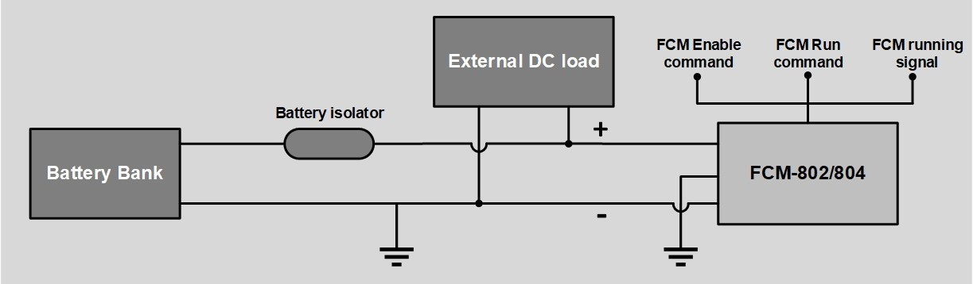
IE-POWER 3/4

Warning: Do NOT electrically overload the P3/P4. Overloading will lead to excessive load being drawn from the battery. Drawing excessive load may lead to a shutdown of the fuel cell and load not being supported.

System can be set up for positive ground applications in the factory, please contact Intelligent Energy if this is a requirement.

Cable sizing needs to consider the maximum output current of the unit, acceptable cable voltage drop, cable length, cable grouping and thermal loading etc.

The cable runs should be as short and direct as practicable. The isolator should be rated for the maximum power deliverable in the installed application. See table below:

Description | Max current Deliverable | Conductor Area | AWG
P3 | 80Amps | 26.7mm2 | 3
P4 | 120Amps | 53.5 mm2 | 0

Note: Do not connect more than one cable connector lug to the positive and negative terminals. If multiple FCMs are connected in parallel terminate to a central distribution board. For more information please contact Intelligent Energy Ltd.

These values are for guidance and must be checked they are suitable for the proposed application.

Note: Do NOT disconnect the main power leads with the enable signal present.

Warning: When the P3/P4 is running it will stay live if the power cables are disconnected.

Warning: EVEN when the P3/P4 is NOT running the cables may still be powered from the load side battery or external power source.

Note: The battery pack must provide power at the desired voltage. The battery pack must be capable of powering the load during module performance optimisation cycle (see section 8.3). For description of the command and signal connections see Section 6.5.

Electrical isolation and over-current protection

Suitable means of isolation must be provided by the installer to isolate both wires between the P3/P4 and the external battery/load. Suitable over-current protection (fuses or circuit breakers) must be provided by the installer between the P3/P4 and the external battery load.

The battery and associated isolation and over-current protection must conform to:

EN IEC 62485-2:2018. Safety requirements for secondary batteries and battery installations. Stationary batteries.

Air supply

To produce electrical power, the P3/P4 requires an unobstructed air supply which must not be recirculated between the exhaust and inlet.

Ensure that the air inlet cannot be blocked

Ensure that the air exhaust cannot be blocked

Do not recirculate the exhaust to the inlet

The air must be free of the following contaminants:

Sulphur

Hydrocarbons

Carbon Monoxide

Ammonia

Hydrogen fuel

The P3/P4 must be set up in a well-ventilated environment with consideration given to the precautions of hydrogen safety. The hydrogen supply needs to be regulated to 650mbar.g (±150mbar.g) and maintain the pressure during rapid changes of flow rate.

When installing and operating hydrogen systems, hydrogen general safety guidance must be considered:

The hydrogen must be at least 99.9% pure and comply with the specification:

ISO 14687-3:2014 grade E category 3

ISO/TR 15916 basic considerations for the safety of hydrogen systems

Hydrogen connection

Note: The hydrogen connection to the system is at the rear of the module just above the communication port (see Section 2 Product Interface). The hydrogen supply is connected via a female G1/8 parallel BSP thread with a face seal. It is required that this is then connected via an appropriate mating connection.

The hydrogen pipework must be checked periodically for leaks, particularly when connectors have been re-connected, such as cylinder exchange or installation.

Communication connection

To operate P3/P4, communications need to be provided through the D-type connector. The pins of the connector have the following functions:

Performance | Function | Specification
1 | Enable | Provides power to the FCM
2 | Enable Positive | Power source for the Enable signal
3 | CAN high | CAN pin
4 | CAN low | CAN pin
5 | CAN return | CAN reference
6 | Run | Starts the fuel cell
7 | Run Positive | Power for the start command
8 | Status | Status indicator
9 | Isolated ground | Ground pin

Warning: Do not use the power ground as a reference for the communications and vice versa.

Warning: Ensure communication cables are not more than 3m long.

CAN connection

The pins for the connector are as follows:

CAN Hi
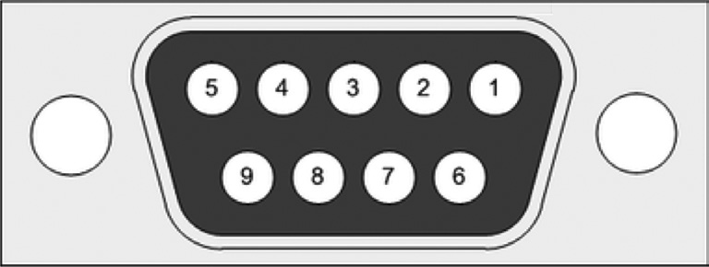
CAN Lo
Isolated 3.3V
CAN RTN (ground)
Enable
The CAN connection can be used to communicate with the P3/P4 using Intelligent Energy’s proprietary CAN protocol.

Potential free contacts

There are four potential free contacts (PFC) for auxiliary signals to and from the FCM.

The PFCs are set up to be one output and three inputs.

These are software configurable by Intelligent Energy. The signals are shown in the following table:

Description | Pins
Input 1 | 1, 2
Output 1 | 3, 4
Output 2 | 5, 6
Output 3 | 7, 8

FCM commands and status

Module enable

To enable the FCM, the Enable pin needs a signal. To provide the signal, a connection must be made between pins 1 and 2.

Module run

To produce power, the Run pin needs a signal. To provide the signal, a connection must be made between pins 6 & 7 (N.B: Enable must also be present). When the signal is received, the FCM will start and maintain the battery voltage.

If the current draw is at a low level (less than 6 Amps as default, for P4) the FCM will go to standby state. The battery voltage will be monitored. If it drops below the nominal battery voltage (user defined Delay Start Under Voltage, see 13 Control Parameters), the fuel cell will then switch back to running mode.

P3/P4 status

A continuous P3/P4 status signal, via the Communication Connection, will be present whilst the fuel cell is running with no fault present and the unit has not moved to standby.

If the Enable is off there is no status signal. If the Enable is on but there is no Run signal, then there will be no status signal present. If the Enable and Run signals are present and there is no FCM status signal then the FCM is in Standby or Fault.

P3/P4 software states

The P3/P4 has five possible states:

Off

Inactive

Running

Standby

Fault


State map for the P3/P4
Shutdown
Standby
Power up
Auto start criteria Auto stop criteria
Starting
Off
Inactive
Running
Shutdown
Fault trip
Power down
Enable off
Fault state

Please note the following points:

The small circle in each state box indicates the condition of the P3/P4 status pin.

This is low (black: ) in all states apart from fuel cell running where it is high

(white: ).

In all states, removing the Enable signal returns the P3/P4 to the module controller off state.

If the P3/P4 enters a fault condition the fault is latched. The Enable line must be cycled to clear it.

For start and stop criteria see section 13 Control parameters and standard factory setting.

Operation of IE-POWER 3/4

Overview P3/P4

The FCM provides regulated DC at nominal 24V or 48V output to a battery bus. The DC bus will be held at nominal voltage by a battery or external supply to act as a hybrid system. In the hybrid system, the battery is used to provide power whilst the fuel cell starts. It supports the load during the fuel cell performance optimisation cycle and while the system is in the standby mode. The nominal operating voltage is factory settable upon request. The hydrogen pressure must be provided in a regulated state to the module inlet. The FCM will generate power when it is given both ‘Enable’ and ‘Run’ signals and detects DC bus and fuel pressure are present.

Anode Purge

As the fuel cell operates, it is necessary to remove water and any impurities from the anode (the hydrogen side of the fuel cell). This is done by exhausting a small amount of hydrogen to the coolant air stream. The hydrogen is mixed with the air stream so that, as the mixture exhausts the module, the concentration is low enough that it will not sustain a flame. There is no impact on power production during anode purge.

Fan Pulse

During normal operation, the P3 or P4 will periodically conduct an optimisation cycle which improves the performance of the fuel cell. Multiple cycles are triggered in rapid succession at start-up. Cycles occur less than 15 times an hour during running.

Power production is reduced or suspended for up to 12 seconds during the cycle so an external power source may be needed to briefly provide power to the load.

Standby State

As a fuel saving measure the P3/P4 will stop producing power if the load drops below 6A, default for P4 (see Delay Stop Under Current, 13 Control Parameters) for more than a minute; below this point, the ancillary equipment compromises the fuel cell efficiency. The load will then be provided by the battery. The P3/P4 will continue to monitor the battery and, if its voltage drops below the nominal voltage, it will restart (See Delay Start Under-Voltage in Section 12).

When the fuel cell is running, it will power the load (if present) and float the battery voltage to the nominal set-point. This feature is designed to achieve the maximum useful energy from the fuel available.

Fault State

If the parameters of the P3/P4 leave the normal operational range then a fault is triggered. When a fault has been triggered the controller will latch. To clear the fault, the controller needs to be turned off via the Enable signal. For reset instructions see Section 9.

Optimising the Fuel Consumption of P3/P4

The fuel cell uses the hydrogen to produce electrical current (plus water and heat). The cell eﬃciency can be improved with the following steps:

Products will be most efficient if used often. The FCM should be run at more 15 than 80% power for 30 minutes, at least once a quarter.

Products will be most efficient, and have longer life, if operated at between 50% and 100% power.

Products will be most efficient if operated between 10°C – 20°C.

Faults

Procedure to reset the fault

If the P3/P4 has a fault it will disconnect the internal DC-DC converter and stop providing power. To reset a fault, follow the procedure below:

Check that the load is disconnected

Switch the Enable signal to ‘Off’

Wait for five seconds

Return the Enable signal to ‘On’

Set the Run signal to ‘On’

Return the load to required setting

Note: The safety case of the overall installation must consider the fault condition of the fuel cell as part of its analysis of the full function of the system.

Installation and set up

Mechanical mounting points

The P3/P4 must be installed as a standard 19" rack unit. This should then be mounted on a flat surface with four retaining points, these must be tightened to a torque not exceeding 25Nm. When installing the FCM, inspect it and do not install if there is visible damage to the unit. Any surfaces in contact with the FCM must not be above +50°C. The FCM is 473mm deep (+45mm for the connection terminals) Allow at least 50mm to the rear of the FCM for the cables/pipes to run in.

It is recommended to mount on a shelf with front and rear access for maintenance activity, as shown below:

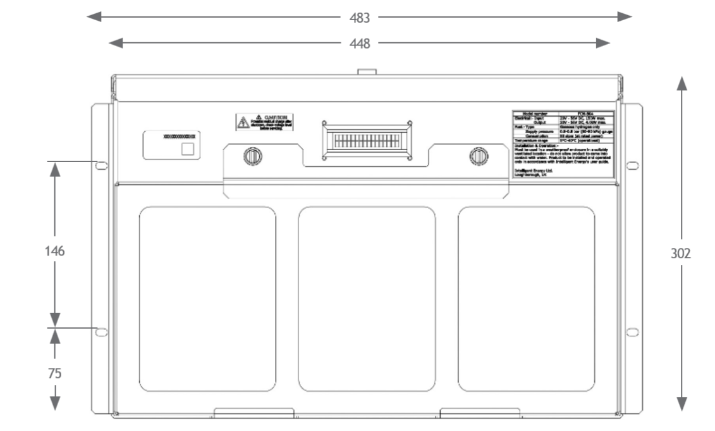

Mechanical protection and covers

The P3/P4 must be mounted with protection from weather and the elements. The P3/P4 has been designed to comply with IP20 rating, it must be mounted within an enclosure which is at least IP24 if used outside.

The covers of the unit must not be removed by unauthorised personnel. The unit contains live electrical components which could be hazardous, even when not operating. The covers and the installation must protect the P3/P4 from precipitation and vegetation ingress. The covers must consider the need for maintenance.

Warning: Do not remove the lid.

Warning: Do not remove terminal cover during operation.

Mechanical connection to the power terminals

It is important to use the correct procedure to connect the power terminals.

Incorrect procedure could damage the unit if excessive torque is used, apply a torque of 5.6 – 6.8Nm. Excessive load may distort the internal busbars.

The power terminals of the FCMP3/P4 are provided with terminal covers in two types, a rubber flexible cover and a rigid snap-on cover, their application is dependent upon the size of the conductor selected for the installation. The rigid cover is more suited to smaller cable and crimp combination (typically up to 18mm wide crimps), and the flexible cover is for larger cable/crimp combinations.

The rigid snap-on cover features a locating slot (see image below) that allows the user to slide the cover over the FCM terminal once the mains DC cabling has been terminated. The rubber flexible cover must be threaded onto the conductor (cable/ crimp) prior to termination. The rubber flexible cover features a sealing ring (see image below) that must be attached to the FCM terminal once the mains DC cabling has been terminated.

Warning: During Electrical maintenance/installation the FCM must be off and the load side battery or external power supply must be made safe.

Warning: Terminal covers must always be fitted, red positive terminal cover to red positive cable, black negative terminal cover to black negative cable.
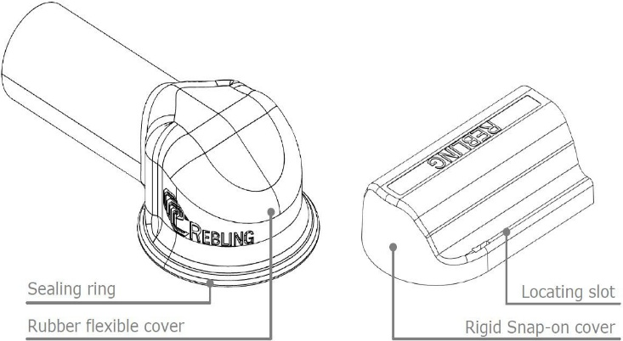

Mechanical connection to the Ground terminal

As standard the P3/P4 is provided negatively earthed. Positive earth version is available as a factory configurable feature. The Ground terminal is a M8 stud located between the two power terminals and should be used to earth the unit. The cable should be sized to provide protection to the unit during operation and in foreseeable fault conditions.

Warning: The FCM chassis earth must be connected prior to the mains DC negative and positive terminations, additionally the FCM chassis earth must be disconnected after the mains DC negative and positive terminations.

To install and remove the earth termination please following the process below:

Two spanners (13mm).

One to hold first nut to prevent it from rotating. There is a lock nut at the back holding the stud in place, which must not be adjusted.

The other to tighten the second nut to secure cable/conductor terminal against first nut, apply a torque of 8 N.m.

Vibration and shock loads

The mounting of the P3/P4 must ensure that it is not exposed to shock or vibration loads. Ensure that the P3/P4 is stationary while it is operating.

Note: If the FCM has been stressed due to vibration or shock, return to Intelligent Energy for investigation.

Hydrogen connection

The P3/P4 requires hydrogen to fuel the electro-chemical reaction. Connection of the hydrogen fuel will be at the rear of the module. The connection type is a female G1/8 parallel BSP thread with a face seal, this must be connected via an appropriate mating connector. At installation the external hydrogen pipework must be bled of air or inert gas before operation. The hydrogen pipework must be checked periodically for leaks.

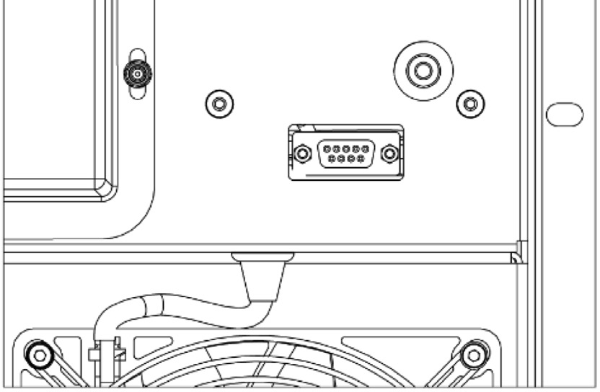
Hydrogen Connection

Hydrogen fuel physical requirements

The P3/P4 requires regulated fuel pressure to feed hydrogen into the cell. The inlet pressure for operation must be:

500mbar.g to 800mbar.g

The P3/P4 will consume less than 70g/kWh at rated power. This is equivalent to 34slpm (P3) and 56slpm (P4) at rated power. It must be noted that the flow will spike high during hydrogen purges, which, if poorly regulated, can lead to a low pressure fault of the FCM.

It is required that the external system has an automatic shut-off valve as part of the hydrogen feed line. This allows the hydrogen to be isolated at source if required

Maintenance procedures

User maintenance

The user can perform the following maintenance on the P3/P4:

Monthly filter inspection

Filter change

Troubleshooting (see below)

Not performing these basic checks will reduce unit efficiency. For all other maintenance tasks, contact Intelligent Energy Ltd.

Contact Intelligent Energy Product Support Team

In the event of a fault with the P3/P4, please contact the Intelligent Energy Product Support Team. Either contact your local representative or email:

servicing@intelligent-energy.com

Please have the part number of your product and the serial number (on the

name plate). The part numbers are:

P3: 10004360

P4: 10004361

Troubleshooting guide

Possible causes of faults

Fault | Cause | Action
No power from the module | No command to start | Verify that the module is in Enable and Run modes (see section 6.5 Communications)
No power from the module | Hydrogen leak | See 12.2 Check for fuel leak
No power from the module | Incorrect hydrogen pressure | See 12.3 Fuel check procedure
No power from the module | No power provided | See 12.4 Electrical system check procedure
 | Fuel cell is over temperature | See 12.5 Stack temperature check procedure

Check for fuel leak

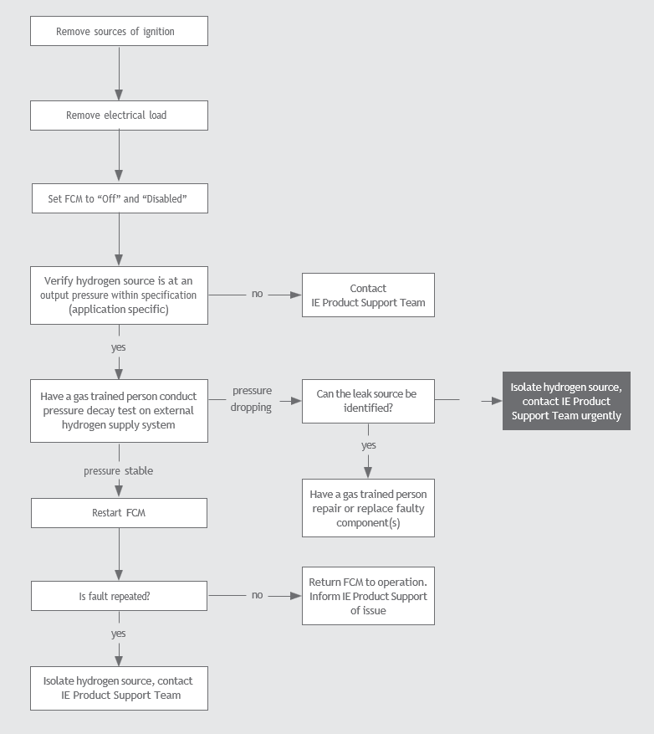
no

Fuel check procedure

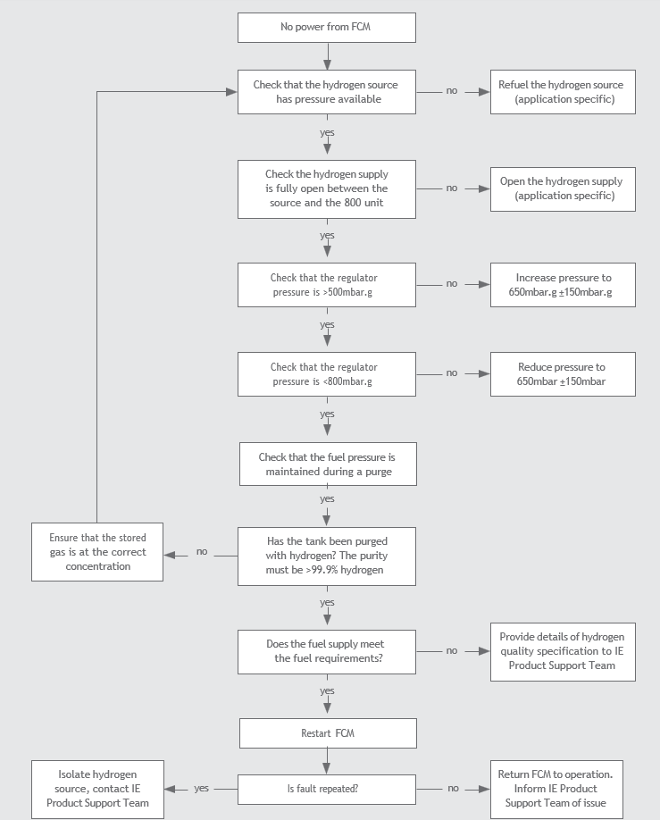

Electrical system check procedure

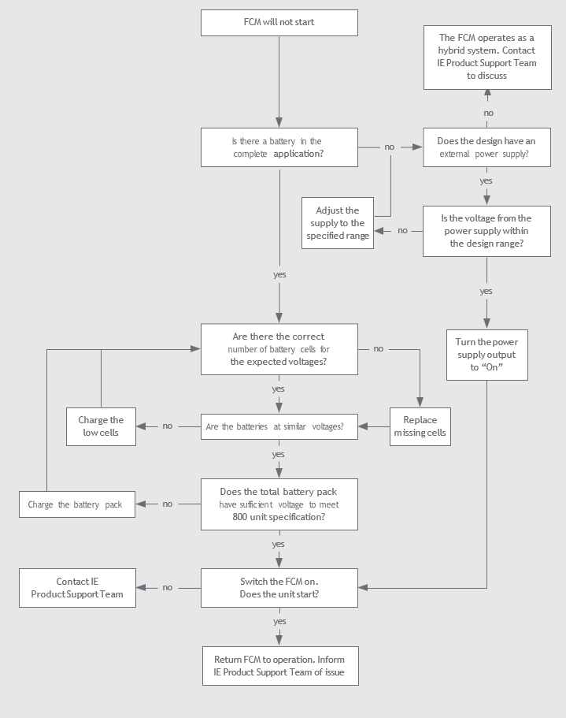

Stack temperature check procedure

Fuel cell not operating or derated
Is the max load within the unit specification?
no
yes

Is the operating temperature within the specification range?
no
yes

Does the air inlet filter look choked?
yes
Replace filter
no
Is fault repaired?
no
yes
Restart FCM
Return FCM to operation.
Inform IE Product Support Team of issue
Isolate hydrogen source, contact IE Product Support Team

Filter change procedure

1 Switch off the Enable and Run signals.

2 Isolate hydrogen supply.

3 Wait 15 minutes.

4 Remove two quarter turn thumb screws from the frame on the front of P3/P4.

5 Remove the retaining clamp.

6 Pull top of frame forward.

Note: Take care not to touch the fuel cell. Potentially live components

7 The dirty filter can be lifted out.

8 Discard dirty filter.

9 Place clean filter in front of P3/P4 and refit frame and screws.

Warning: Do not touch the fuel cell stack during this procedure

Control parameters and standard factory setting

The IE-POWER series configuration is factory settable. If there is a need to adjust the configuration after installation contact Intelligent Energy Product support.

Power setup configuration (P3)

Parameter | Unit | Range | Factory Setting (24V) | Factory Setting (48V)
Target Output Voltage | V | 15.0 to 56.0 | 26 | 52
Delayed Start Under-Voltage | V | 0.0 to 60.0 | 24 | 48
Delayed Start Qualification Time | s | 0 to 14400 | 60 | 60
Immediate Start Under-Voltage | V | 0.0 to 60.0 | 22 | 46
Delayed Stop Over-Voltage | V | 0.0 to 60.0 | 32 | 54
Delayed Stop OV Qualification Time | s | 0 to 3600 | 60 | 60
Delayed Stop Under-Current | A | 0.0 to 120.0 | 4 | 4
Delayed Stop UC Qualification Time | s | 0 to 3600 | 20 | 20
Deny Start Under-Voltage | V | 0.0 to 50.0 | 20 | 40
System Index | - | 1 to 8 | 1 | 1
Output Voltage Rise Rate | V/s | 0.017 to 2000.00 | 0.017 | 0.017
Minimum Output Voltage | V | 0.0 to 60.0 | 24 | 48
Output Current Limit | A | 0.0 to 80.0 | 60 | 80
Hard Set Output Voltage | - | 0 or 1 | 0 | 0
Output Power Limit | W | 0 to 2400 | 1920 | 2400
Restart Delay | s | 0 to 3600 | 20 | 20

Power setup configuration (P4)

Parameter | Unit | Range | Factory Setting (24V) | Factory Setting (48V)
Target Output Voltage | V | 15.0 to 56.0 | 26 | 52
Delayed Start Under-Voltage | V | 0.0 to 60.0 | 24 | 48
Delayed Start Qualification Time | s | 0 to 14400 | 60 | 60
Immediate Start Under-Voltage | V | 0.0 to 60.0 | 22 | 46
Delayed Stop Over-Voltage | V | 0.0 to 60.0 | 32 | 54
Delayed Stop OV Qualification Time | s | 0 to 3600 | 60 | 60
Delayed Stop Under-Current | A | 0.0 to 120.0 | 6 | 6
Delayed Stop UC Qualification Time | s | 0 to 3600 | 20 | 20
Deny Start Under-Voltage | V | 0.0 to 50.0 | 20 | 40
System Index | - | 1 to 8 | 1 | 1
Output Voltage Rise Rate | V/s | 0.017 to 2000.00 | 0.017 | 0.017
Minimum Output Voltage | V | 0.0 to 60.0 | 24 | 48
Output Current Limit | A | 0.0 to 120.0 | 105 | 120
Hard Set Output Voltage | - | 0 or 1 | 0 | 0
Output Power Limit | W | 0.0 to 4000 | 2880 | 4000
Restart Delay | s | 0 to 3600 | 20 | 20

Spare parts, storage and disposal

Spare parts

The customer changeable spare part list is:

Air filter 10004602

Terminal cover 10005293

Only use Intelligent Energy approved parts.

Disposal

When the P3/P4 reaches end of life, please contact Intelligent Energy Product Support or your local representative for support with reconditioning or disposal.

Storage

The P3/P4 must be stored as follows:

The P3/P4 must be stored level, resting on the base

The P3/P4 can be stored in temperatures between -40°C and +70°C

However, the ideal temperature for storage is between +10°C and +25°C

The P3/P4 must be protected from moisture and dust during storage

The P3/P4 hydrogen inlet port must be protected during storage

Transportation

For transport, follow the guidance for storage taking care that:

The P3/P4 original packaging MUST be retained for transportation and returns purposes

The P3/P4 must be transported in a level orientation

The P3/P4 must not be subjected to mechanical shocks where possible

The P3/P4 must be protected from moisture and dust during transport

The P3/P4 hydrogen inlet port must be protected during transport

Declaration of Conformity

In accordance with EN ISO 17050-1:2010

This Declaration of Conformity is issued under the sole responsibility of the manufacturer:

Intelligent Energy Limited

of

Charnwood Building, Holywell Park, Ashby Road, Loughborough, Leicestershire, United Kingdom, LE11 3GB

In accordance with the following Directive(s):

2006/42/EC The Machinery Directive

2014/30/EU The Electromagnetic Compatibility Directive

2014/34/EU The ATEX Directive

2011/65/EU The RoHS 2 Directive

Intelligent Energy Limited hereby declares that:

P3 – 2.5kW Standalone Stationary Power Fuel Cell Module (Negative Earth)

Part Number: 10004360

and

P4 – 4kW Standalone Stationary Power Fuel Cell Module (Negative Earth)

Part Number: 10004361

Are in conformity with the applicable requirements of the Directives set out above and the following standards documents:

EN 60079-10-1:2015 Classification of areas – Explosive gas atmospheres

EN 61000-6-2:2005 Electromagnetic compatibility (EMC) – Generic standards – Immunity for industrial environments

EN 60204-1:2006+A1:2009 Safety of machinery – Electrical equipment of machines – General requirements

EN 62282-3-100:2012 Fuel cell technologies – Stationary fuel cell power systems – Safety

EN 61000-6-4:2007+A1:2011 Electromagnetic compatibility (EMC) – Generic standards – Emission standard for industrial environments

EN 62061:2005 Emission standard for industrial environments – Safety of machinery – Functional safety of safety- related electrical, electronic and programmable electronic control systems

EU authorised representative:

Certification Company

Veluwezoom 42, 1327 AH, Almere

The Netherlands

Signed for and on behalf of Intelligent Energy Limited:

Dr Chris Dudfield Chief Technical Officer

Intelligent Energy Limited,

Charnwood Building, Holywell Park, Ashby Road, Loughborough, Leicestershire, United Kingdom, LE11 3GB

19th December 2018 Document Ref. No. 273-DOC-1852

© Intelligent Energy Limited 2025. All Rights Reserved. The Intelligent Energy name, logo, and other trade brands/names referenced herein are trademarks or registered trademarks of Intelligent Energy Ltd or its group companies, whether or not they are used with trademark symbol “TM” or “®”

The information contained herein is the intellectual property of Intelligent Energy Ltd and it may not be copied or reproduced in any format.

The information contained in this publication is intended only as a guide and is subject to change as a result of the constant evolution of Intelligent Energy’s business and its technology. This publication and its contents do not include all details which may be relevant to particular circumstances and should not be regarded as being a complete source of Information. To the fullest extent permitted by law, Intelligent Energy offers no warranty as to the accuracy of the content of this publication, shall not be liable for the content of this publication and no element of this publication shall form the basis of any contractual relationship with a third party. Printed URM-27057 version 1.0

Published by: Intelligent Energy Ltd, Charnwood Building, Holywell Park, Ashby Road, Loughborough LE11 3GB. Tel: +44 (0)1509 271271 (Registered in England with company number: 03958217).

